**Customer Retention Plan for Maven Telecom.**

**A Report By Daniel Gaza;**

**1.Introduction**

Maven analytic holds competitions every month to help aspiring data analysts and other data-related roles sharpen and showcase their skills. The competition in July 2022 was on a telecom company. Maven analytics required a one-page report with visualizations, insights, and recommendations. The full processes and steps taken in the analyses cannot be detailed in full on a single page report, thus this report.

This report includes the entire process of developing a hypothesis, preparing data, analyzing data, and drawing conclusions/recommendations from the analysis. To make this report more interesting, we will create Maven Telecom, a telecom company that will own this data.

With the year coming to an end, it is a good practice to review how the company/business performed throughout the year to assess profit and loss, where failure occurred and how to prevent it from happening again, and planning for potential problems that will arise in the coming year.

Maven Telecom is a California-based telecommunications company. The analysis department has been tasked with determining the causes of churn, as well as how to prevent and mitigate it. The analytic lead assigned me the task of analyzing and developing insights from the company's 2022 first quarter records.

* 1. **Objective Of Analysis**

Maven Telecom has noticed a decrease in customers and wants to figure out why and how to stop or prevent this from happening again.

Maven Telecom tasked the analytics department to investigate the business to determine how many customers were lost (churned) over the course of the first quarter and to improve retention by identifying high value customers and churn risks in order to set preventive measures against them in the coming quarter.

* 1. **Statement of Problem**

Maven Telecom's first quarter in 2022 was favorable; however, in order to plan for the second quarter, Maven Telecom must understand where they fell short so that improvements can be made and high-value customers can be leveraged. Churned customers, customers who left and the reason for their decision, to avoid further customer loss, as the saying goes, it is easier and less expensive to keep a customer than it is to bring in new customers. The records contain many attributes describing the customers, which we will use to understand the customers, as well as what is discouraging the customers from living. High-value customers, what has kept them? By answering this question, we will be able to combine results to provide detailed steps for Maven Telecom to use in order to keep their customers while also bringing in new ones.

* 1. **Analysis Questions**

The goal of the analysis is to improve retention by identifying high-value customers and churn risks. We will divide this into two questions, each of which will be further divided into sub-questions.

1. Identification of high value customers;

To identify high value customers, we will use attribute from the record such as

1. Using the records attribute (columns)to determine high value customers e.g., Monthly charge, Total charges, extra data charges premium Tech Support etc.
2. Identifying cities with more customers and going further to see cities with these high value customers.
3. Using our services and product to identify high value customers e.g., internet type, offer, contract etc.
4. Churn ricks;

We can see from the record that we have customers who churned; we will conduct a deep dive to determine the reason for churn and whether our services influenced this.

**2.Data**

This is our customers' record as of the end of the fiscal quarter (Q1 2022). This date is reserved for customers in the first quarter of 2022. The record has 38 columns and contains customer information such as age, address, services used, retention information, and payment method, among other things (this is a public dataset available on mavenanalytics.io). The data used in the analysis is a csv file, will be using excel in carrying out the analysis and power bi in creating visualizations and a dashboard/ report they will hold all visuals in one page.

Customers are divided into three categories: stayed, churned, and joined. Stayed customers are those who are still with us, churned customers are those who left between the beginning and end of the first quarter, and joined customers are those who have recently joined.

* 1. **Tools Used**

After the data has been collected, cleaned, and stored in our database, we will use Microsoft Excel and Power BI in this analysis. I'll be using Excel to collect the data, clean it up, and run the necessary analysis. To visualize the results of the analysis processes, I will create and share reports in Power BI.

**2.1 Data Cleaning and Wrangling**

It is always a good idea to clean the data you intend to work with; remember, "your results are only as good as the data." While most data may appear to be prepared at first glance, it is important to take the time to inspect the data for any inconsistencies that may affect our results. Maven analytics Engineering team ran cleaning processes on the data before storing it in our warehouse.

I cleaned by checking the consistency of the records in our table, spelling, and if there are any Null rows or columns and why they are empty. After finishing the cleaning and preparing process. We discovered empty cells, but this was due to customers not using some of the services we provided.

To improve the analysis process, **added** column called "Years with company" was added to the record. This is the result of converting the months to years; the Tenure in Months column shows how long (in years) each customer has been with the company in each month.

**3. Exploratory Data Analysis**

**3.1. Idenfitication of High Value Customers.**

Maven Telecom has tasked us with identifying high-value customers. High-value customers are the people who drive a company's growth. Knowing and keeping these customers is critical to the company's success. We will use Excel to see if there is any relationship between services and customers that can be used to determine how much we value customers.

**Cities**

Looking at our cities of operation from a broad perspective to identify high performance cities. Cities with more customers, cities with more customers, are cities that generate more revenue and thus have a higher value. By delving deeper into these cities, we can learn more about these customers and how Maven Telecom has been able to retain them, and similar measures could be applied to other states to achieve similar results. The risk of churn will be mentioned. Later, we can see from the data that some customers left the company for one reason or another, and we can figure out how Maven Telecom was able to keep these customers, so that these steps can be duplicated and used to save more customers and the business.

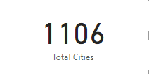

Maven Telecom operates in 1106 California cities; we want to determine the most profitable cities before drilling into the cities to assess high-value customers. The cities with the most customers are the most profitable. We can now drill into these cities to see how Maven Telecom has been able to keep them so far away and how this can be replicated.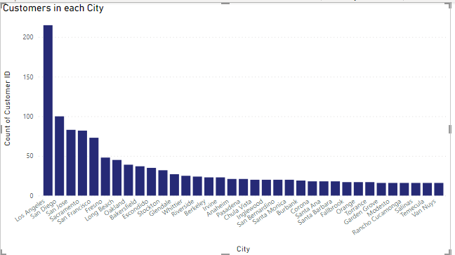

Due to the large amount of data, this is a column chart that only shows the number of customers in the top 30 cities.

**Number of Dependents**

This column contains data on the number of dependents who live with the customer (dependents could be children, parents, grandparents, etc.). It indicates the number of dependents each customer has; customers with dependents may be potential Maven Telecom customers. They may be drawn to become customers themselves as a result of the referrer, and if the customer subscribes to phone service, this may be an addition to the company. This referrer program will be active when such customers have not previously subscribed to phone services and excludes churned customers.

**Offer B and Offer E**

Offer B attracted the most customers, followed by Offer E, but the majority of them churned. Offer E made a total of $243,452.10 with 805 customers, while Offer B made $4,187,916.77.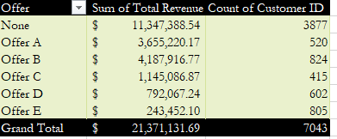

**Fiber Optic**

In the first quarter, fiber optic internet was the most profitable, bringing in $12,408,074.43. This is to be expected, as fiber optic is the fastest internet type provider by Maven Telecom.

**Two Year**

Customers who sign up for a two-year contract generate the majority of the company's revenue, with total revenue at the end of the first quarter standing at $9.036,849.16. Interestingly, the month-to-month contract has the most customers subscribing to it and the lowest revenue generation, with customers accounting for 51.26% of total customers.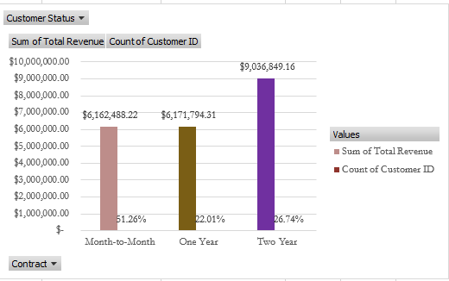

**Extra Data Charge**

Customers who received extra data charges in the first quarter that were not specified in their plan are considered high value customers. Customers who received extra data ranging from 10gig to 150gig should be closely monitored to see if the pattern repeats itself in the coming quarters.

**Long Distance Charges**

Long distance charges generate more profit because customers must pay extra to make long distance calls, which generates revenue for the company.

**3.2 Churn Risk**

One of the primary goals of this analysis is to determine churn risk, why customers have left, and what is more likely to cause others to leave. Using this information to prevent further customer loss.

According to our data, 1869 customers churned, implying that 1869 customers were lost.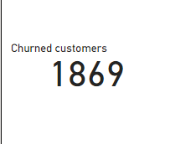

In this section, we'll delve deeper into the reasons why customers leave and how Maven Telecom can prevent this from happening again.

To understand our customers, particularly those who are at risk of churning, we must first understand the churn customers.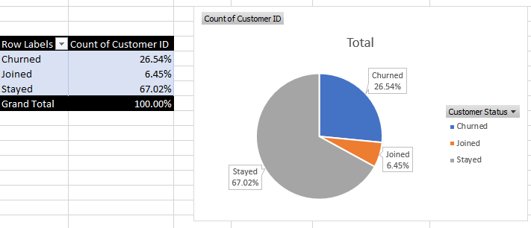

We can see that the churn rate is at 26.54%, which means that this percentage of customers has already been lost, but Maven Telecom still has 73.47% of customers (the combination of stayed and joined percentages) who are still with the company, and without further analysis, Maven Telecom risks losing these customers.

Going deeper, we can identify customers who are likely to churn using other attributes of our customers and services provided, so that adequate attention can be given to this group of customers.

**Not Married:** According to our data, customers are more likely to churn when they are not married and more likely to stay when they are. Maven Telecom will have to come up with incentives and measures to prevent any further losses after 370 newly joined customers, or 81.50% of newly joined customers, are not married.

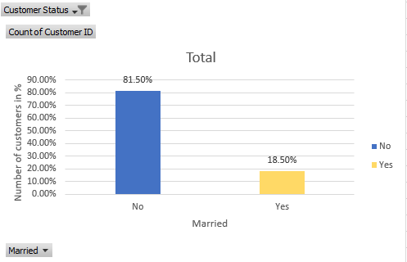

**Offer E**: Although the majority of customers who churned did join using any offer, with 56.23% doing so, offer E has the highest number of offers used in joining the company that have churned at 22.79%. We discovered that 61.45% of newly joined customers used any offer, while 38.55% used Offer E.

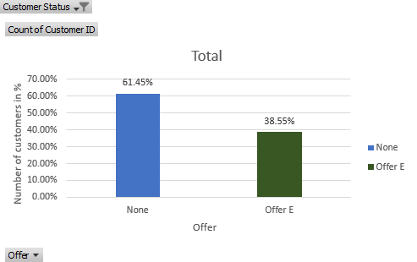

**Fiber optic:** Understanding the data pattern reveals that churned customers opted for fiber optic internet type, while 22.25% of joined customers segment joined and opted for fiber optic internet type.

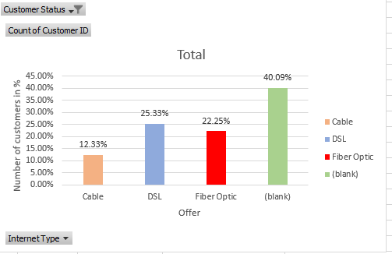

**No online security:** We discovered that 78.17% of churned customers did not subscribe to online security, and we discovered a likely risk from Maven Telecom data, from the segment of newly joined customers, where 49.78% of the joined customers do not subscribe to online security.

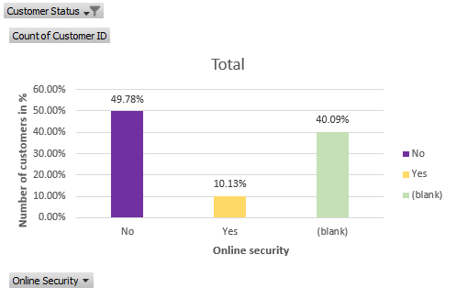

**Month-to-Month:** In order to prevent further customer loss, we must use information from churned customers to determine why they churned and recommend steps to prevent further customer loss. The majority of churned customers (88.55%) subscribed on a month-to-month basis, and we can see that 89.87% of newly joined customers subscribe using this customer type..

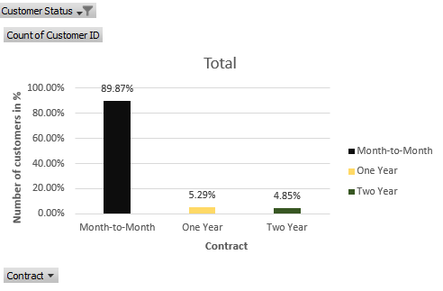

**Churn Reasons**

In the Maven Telecom record, we can see that the customer service department classified customer complaints into categories that they fall into, providing us with a comprehensive view of the reasons for customer churn.

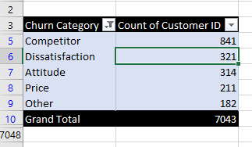

The categories of churn reasons for customers leaving can be seen in the pivot table above.

With competitor having the largest customers churn falling under this reason, following we have dissatisfaction maybe with the services or the staffs we will have to go deeper to know this. Attitude and price come next, to have better understanding we have to expand the categories to under each complaint of each customer, since these are in aggregated form. We are going to expand the categories hierarchically.

**Competitor:** With competitor being the most common reason for customer churn, let us investigate the root causes of customer churn. Remember that the goal is to calculate our churn risks and then create solutions to those problems.

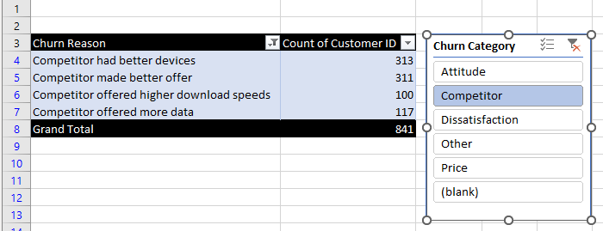

According to the complaints of the majority of customers who churned, competitors appear to be providing better services. Competitors have better devices, better offers, faster download speeds, and more data to offer. If Maven Telecom wants to stay ahead of competitors and keep customers, it must investigate this thoroughly.

Expanding further with cities, we can narrow down to cities where competitors have complained. Using the available data, we can see where our competitors are providing better services than Maven Telecom, resulting in customer loss. Maven Telecom should use this information to provide more superior services, which could tip the scales in her favor.

**Dissatisfaction:** The second recorded complaint is dissatisfaction; 321 of the 1869 churned customers were dissatisfied with our products and services.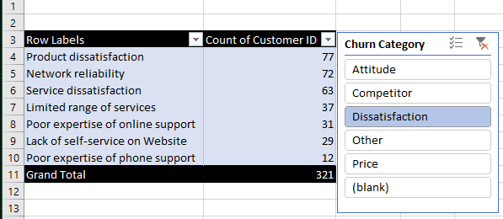

This pivot table displays the reasons for dissatisfaction among churned customers, such as dissatisfaction with our products and services, poor online support expertise, and so on. Solutions to these various reasons should be implemented as preventive measures to prevent further customer churn.

Customers are dissatisfied for a variety of reasons, including poor online support, service and product dissatisfaction, and network reliability. Knowing which cities these dissatisfied customers are from allows Maven Telecom to better deploy means in countering the damages and preventing them in other cities.

**Attitude:** Complaints were received regarding the attitude of Maven Telecom employees, with the category being broken off to see the reasons customers complained about, in order to better disarm the problem. With the goal of stopping or preventing it from happening.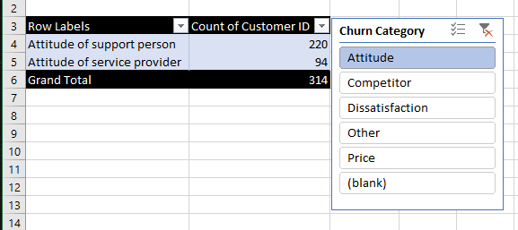

**Stopped**

314 of 1869 churned customers received poor customer service from support personnel and service providers. Businesses are created to provide services to customers, and poor customer service is a sign of a bad business model that must be investigated.

We can expand further into cities to see where these complaints are coming from and precisely solve them. We can assess the specific states where customers have reported these issues in order to prevent them from recurring. Applying the solution to all cities is a fantastic idea for establishing preventive measures so that they do not occur in other states.

**Price:** Price complaints accounted for 211 complaints, with reasons ranging from prices being too high to the cost of products and services being too high; for these customers to churn, competitors appear to be offering low prices on better offers and services.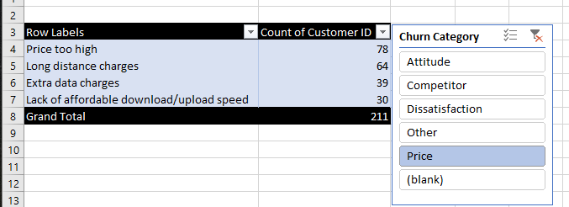

Maven Telecom will have to come up with measures for better products and services to meet prices or cut prices to retain customers, because customer loss is already at 26.54% drastic measures will be required to counteract the damage already done.

**Others:** Under the final category, we find reasons such as some customers not knowing why they stopped using Maven Telecom services, 46 others having moved out of the country, and 6 having died.

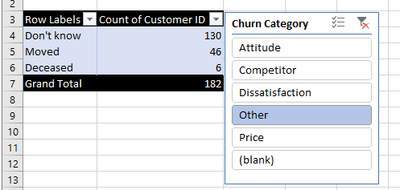

We have seen and understood the categories and reasons for churn, looking into the record from a different perspective to better understand the patterns and come up with the best possible solutions to these various reasons.

**4. Results and Discussion**

Putting it all together based on Maven Telecom data analysis, with a focus on improving retention by identifying high-value customers and reducing churn risks. We were able to delve deep into the data to identify attributes, patterns, and behaviors of high-value customers in order to foster retention, as well as customers at risk of churning based on the pattern already established by churned customers (customers who have left). All of this was done to improve customer retention and reduce further customer loss in the coming quarter.

Maven Telecom customers were divided into three groups: those who stayed, those who churned, and those who joined. Customers who left during the first quarter and customers who joined during the quarter were churned. Maven Telecom's total revenue in the first quarter was $21,371,131.69; however, due to customer churn, the company will lose $3,684,459.82 in the following quarter. We can see from the first quarter data that Maven Telecom is not doing well in terms of customer recruitment. With a churn rate of 26.54% of 7043 customers and only a 6.45% gain in new customers, this is not a good look for the company. As a result of the analysis, we dug deeper into the data to see if we could uncover the reason for the high rate of customer loss.

Based on the research we conducted to better understand our customers, we discovered that female customers are more likely to churn, especially if they are not married. When a customer is female and not married, there is a 0.51 correlation coefficient of churning. When we categorize the newly joined in this term, we can see that more than 82% of the customers are not married, which is risky. Because fiber optic is the fastest internet type offered by Maven Telecom, it stands to reason that it has the highest subscription of any internet type offered.

The promotion of offer E brought many customers; considering it was a low-cost offer, this could be the reason for its success; it could be replicated; however, improvements must be made to this offer; the churn rate is higher with this offer. It has failed to retain customers despite attracting a large number of them. Customers who signed up for a month-to-month subscription are more likely to churn, and the majority of Joined customers have done so far.

Going further with the reasons for customer churn, the majority stated that competitors offer better services and products than Maven Telecom, which is very concerning. Prices are too high when combined with poor products and services, a poor attitude from staff toward customers, and a lack of expertise in online support. Customers will not pay a high price for poor services; it is illogical; Maven Telecom will have to improve her services to match the already set price.

**5. Insights**

These are the insights derived from analysis of Maven Telecom first quarter data

* Offers B and E were the most successful promotions in comparison to the others. However, the churn rate is higher among customers who joined Maven Telecom using Offer E; the majority of newly joined customers joined during the Offer E promotion. Offer E is the least popular among customers who stayed. This appears to be the cheapest offer.
* Fiber optic is more preferred by customers.
* Customers are more likely to choose a plan with unlimited data.
* 728 customers paid for additional data, and only 445 remain with the company; these are high-value customers.
* Customers who are not married are more likely to churn, and 81.50% of newly joined customers are not married.
* Understanding churned customers, they are more likely to opt for a month-to-month contract, with a correlation coefficient of 0.5 between the two. The Month-to-Month plan was chosen by 89.87% of newly joined customers.
* Meeting the analysis's churn risk criteria, 112 customers are at risk of churn, resulting in a revenue loss of $40,762.84.
* Customers are likely to churn when they are not subscribed to online security
* Reasons for churn included competitors offering better products and services, dissatisfaction with service and product provided, attitude of company employees, price being too high, and customer death. In descending order of popularity.
* Customers are more likely to churn when they have only been with Maven Telecom for less than 6 months, and newly joined customers as of the time of analysis have only been for 6 months.

**6. Recommendation**

* Having customers who left due to higher prices and extra data charges, while competitors are providing better and lower prices based on the reasons given why customers churned, it is recommended to increase data offer and match prices while also improving internet speed.
* Staff must be trained in customer service because, according to the analysis, customers have left due to poor treatment from staff.
* With the goal of improving services and products, offer E promotion should be replicated because it has proven to be a successful venture in the past.
* Improvements are required in areas such as website self-service, network reliability, and the various services provided to customers.